**Market Segmentation Analysis of Electric Vehicles Market in India.**

**Amulya Muthoju**

**Date: 27/12/2023**

**Github Link:** [**https://github.com/MAmulya/Electric_Vehicle_Market_segmentation_analysis**](https://github.com/MAmulya/Electric_Vehicle_Market_segmentation_analysis)

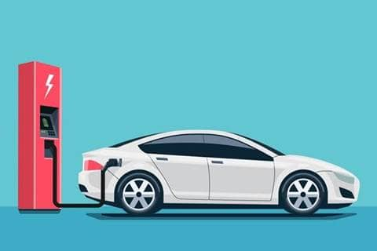

Electric cars are not going to take the market by storm, but it's going to be a gradual improvement*.*

([Carlos Ghosn](https://www.brainyquote.com/authors/carlos-ghosn-quotes))

**Problem Statement:**

Market segmentation becomes a crucial tool for evolving transportation technology such as electric vehicles (EVs) in emerging markets to explore and implement for expensive adoption. EVs adoption is expected to grow phenomenally in near future as low emission and low operating cost vehicle, and thus, it drives a considerable amount of forthcoming academic research curiosity.

The aim is to identify specific groups of potential costumers of a state-of-the-art electric vehicle.

Socio-demographic, psycho-graphic and behavioural variables were included in a questionnaire to identify specific market segments.

**Fermi Estimation:**

In this report we are going to analyse the data and solve the problem using **Fermi Estimation** by breaking down the problem.

A Fermi problem is a problem that involves making a justified estimation about quantities, degrees, probabilities, or variances. Fermi problems are solved by breaking down seemingly impossible questions into smaller and smaller questions. The idea is that eventually, you’ll be able to separate questions that are truly unknown from questions for which you can at least make an educated guess.

Questions we formulated:

1. What type of EV the company will produce? EV bikes, scoties, hatchbacks, sedans, SUV etc.

2. Who are the target customer? i.e. what is age group, income group, professionality, geography etc., of the customer.

**Data Sources and Collection:**

Data was extracted from the various websites mentioned below for EV market segmentation.

* <https://github.com/BairagiSaurabh/Electric-Vehicle-Market-Segmentation/blob/main/Vehicle%20Specification%20Segmentation/ElectricCarData_Clean.csv>
* <https://github.com/BairagiSaurabh/Electric-Vehicle-Market-Segmentation/blob/main/Behavioual%20Segmentation/behavioural_dataset.csv>
* <https://data.worldbank.org/>
* <https://datasetsearch.research.google.com>

**Data Preprocessing**:

Steps taken to preprocess the scraped raw data:

1. Ordinal encoded 'PowerTrain'

2. Label encoded 'RapidCharge’

3. Used Label Encoder and Standard Scaler package for preprocessing of the dataset.

4. Renamed some columns and converted int data type to float.

**Exploratory Data Analysis:**

An Exploratory Data Analysis or EDA is a thorough examination meant to uncover the underlying structure of a data set and is important for a company because it exposes trends, patterns, and relationships that are not readily apparent.

The below bar graphs shows the acceleration, speed, range and efficiency of electric cars.

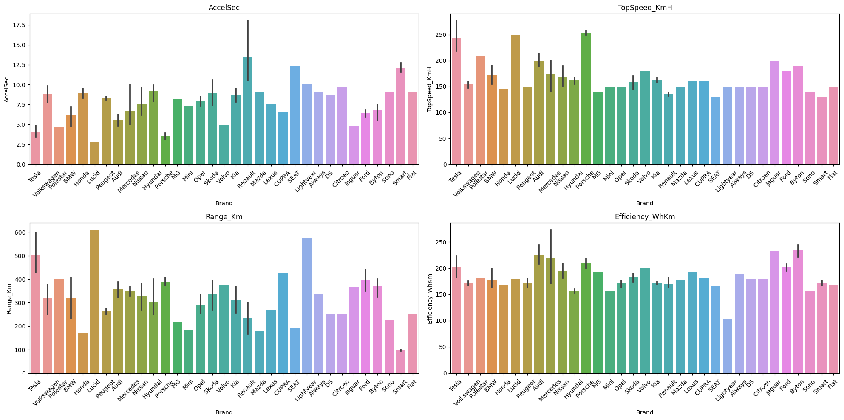

Below graphs shows the count of each entry for consumer features – Age, No.of Dependents, Total Salary, Price.

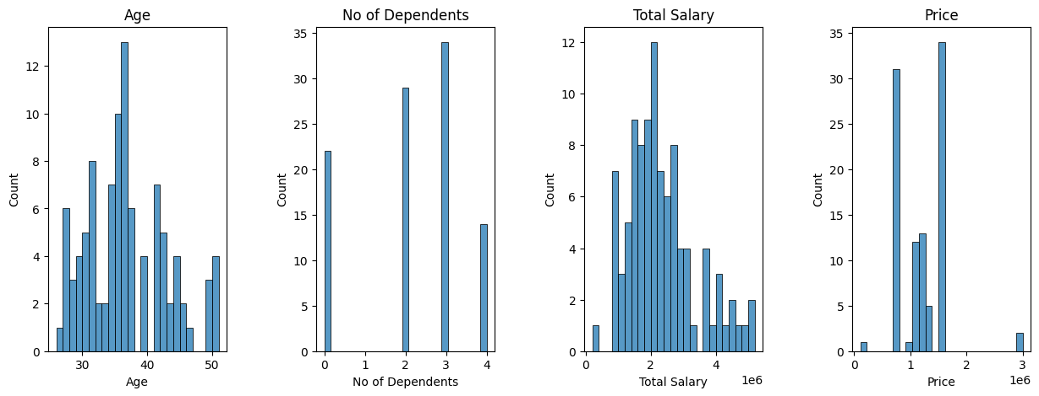

**Correlation Matrix:** A correlation matrix is simply a table that displays the correlation. It is best used in variables that demonstrate a linear relationship between each other. Coefficients for different variables. The matrix depicts the correlation between all the possible pairs of values through the heatmap in the below figure. The relationship between two variables is usually considered strong when their correlation coefficient value is larger than 0.7.

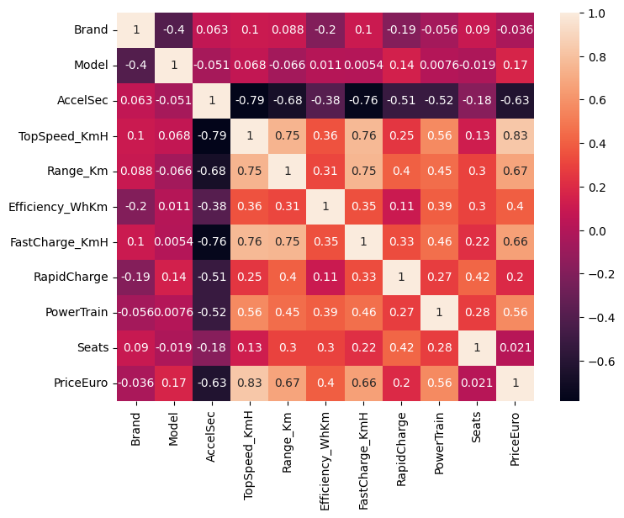

**Segment Extraction:**

K-Means Clustering is one of the most popular Unsupervised Machine Learning Algorithms Used for Solving Classification Problems. K Means segregates the unlabeled data into various groups, called clusters, based on having similar features, common patterns. Suppose we have N number of Unlabeled Multivariate Datasets of various features like water availability, price, city etc. from our dataset. The technique to segregate Datasets into various groups, on the basis of having similar features and characteristics, is called Clustering. The groups being Formed are known as Clusters. Clustering is being used in Unsupervised Learning Algorithms in Machine Learning as it can segregate multivariate data into various groups, without any supervisor, on the basis of a common pattern hidden inside the datasets. In the Elbow method, we are actually varying the number of clusters (K) from 1 – 10. For each value of K, we are calculating WCSS (Within-Cluster Sum of Square). WCSS is the sum of squared distance between each point and the centroid in a cluster. When we plot the WCSS with the K value, the plot looks like an Elbow. As the number of clusters increases, the WCSS value will start to decrease. WCSS value is largest when K = 1. When we analyze the graph, we can see that the graph will rapidly change at a point and thus creating an elbow shape. From this point, the graph starts to move almost parallel to the X-axis. The K value corresponding to this point is the optimal K value or an optimal number of clusters.

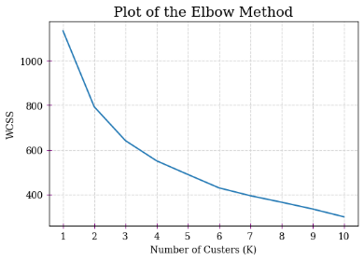

**Profiling Potential Segments**

**Behavioral Segmentation:** Segmenting the market based on customer behavior aspects such as what price range customers usually buy in, what kind of specifications customers look for in their cars, etc.

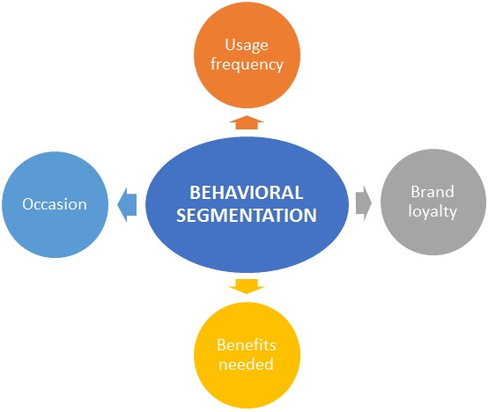

**Behavioral factors:** Most of the customers prefer 5 seated car, and most of the married people prefer to take car loans.

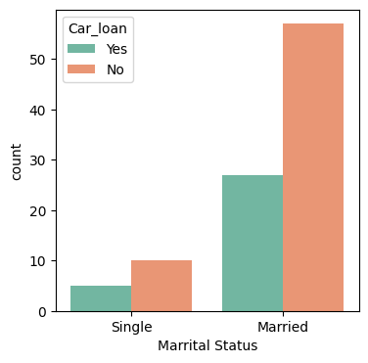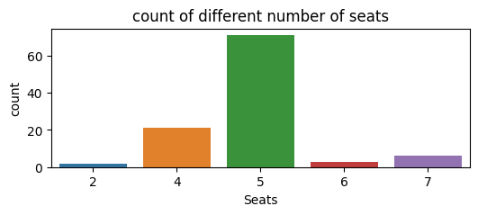

**Psychographic Segmentation:** Segmenting the market based on psychological parameters, such as the likes and dislikes of customers, whether they prefer comfort over speed of a vehicle, etc.

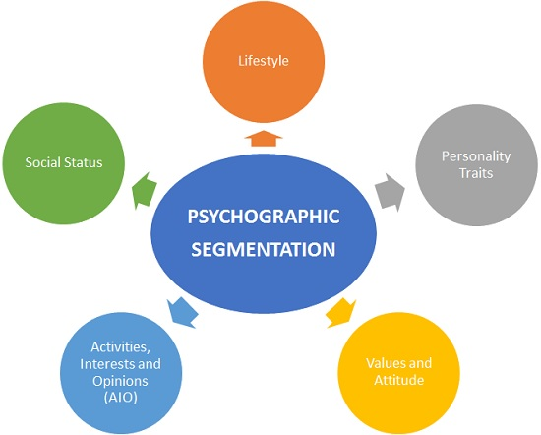

**Psychographic factors:** Comfort, Visual Appeal and Price are other key psychological aspects that attract customers.

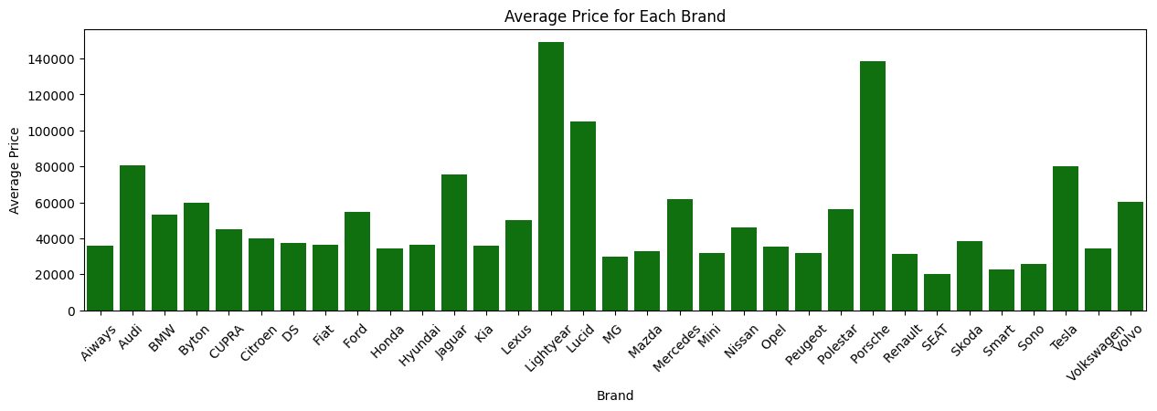

**Geographic Segmentation:** Segmenting the market based on geography. This mainly includes characteristics of the market based on the location.

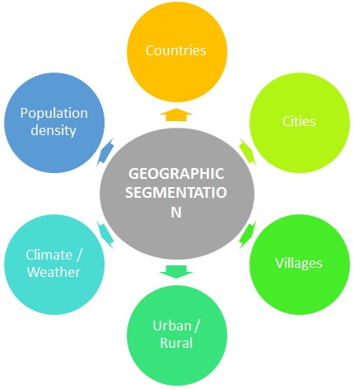

**Geographical factors:**

Most of the 4 wheeler electric vehicles are used in the states of Maharastra and Delhi.

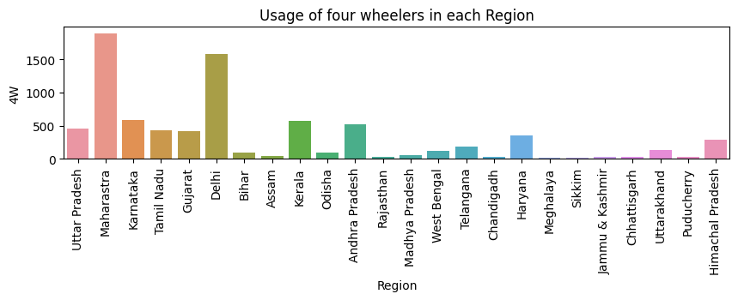

**Selection of target segment:**

Based on the analysis, the target segment can be narrowed down to EVs having:

Psychographic factors such as Comfort and Price

Behavioral factors such as good Acceleration and viable Price range

Geographic factors such as States which are more market friendly.

In conclusion, the target segment should comprise of EVs, High in Comfort with 5 seated having a Price range of 10-16 Lakhs, and be focused mainly on States such as Maharashtra and Delhi.

**Customizing the market mix:**

The marketing mix helps enable the growth of the business in the automotive industry. A company’s marketing mix or 4Ps (Product, Place, Promotion, and Price) specify the approaches and strategies that address the target market, based on the details of the marketing plan. The company’s aim is to maximize sales and improve market presence. With a strong position in the market, However, strategic decision-makers must allow for flexibility in relevant strategies. The automotive market has various opportunities for the growth, such as opportunities for products that integrate advanced computing technologies. However, the company faces threats in its business environment. Managers can use the SWOT Analysis to determine appropriate adjustments in the marketing mix or 4Ps to deal with these threats and opportunities.

**• Price:** refers to the value that is put for a product. It depends on segment targeted, ability of the companies to pay, ability of customers to pay supply - demand and a host of other direct and indirect factors.

**• Product:** refers to the product actually being sold – In this case, the service. The product must deliver a minimum level of performance; otherwise even the best work on the other elements of the marketing mix won’t do any good.

**• Place:** refers to the point of sale. In every industry, catching the eye of the consumer and making it easy for her to buy it is the main aim of a good distribution or ’place’ strategy. Retailers pay a premium for the right location. In fact, the mantra of a successful retail business is ’location, location, location’.

**• Promotion:** this refers to all the activities undertaken to make the product or service known to the user and trade. This can include advertising, word of mouth, press reports, incentives, commissions and awards to the trade. It can also include consumer schemes, direct marketing, contests and prizes.

All the elements of the marketing mix influence each other. They make up the business plan for a company and handle it right, and can give it great success. The marketing mix needs a lot of understanding, market research and consultation with several people, from users to trade to manufacturing and several others.

**Most Optimal Market Segments**

In the context of selecting the most optimal market segment for our electric two-wheeler vehicles, thorough analysis and evaluation have pointed to Segment 1 as the ideal choice. Representing 39% of consumers, this segment boasts significant opportunities and a large customer base, making it a strategic target for market penetration. Its substantial market potential, coupled with its balanced blend of technical specifications and price range, positions it as the most promising market segment for our electric vehicles.

The recommended technical specification range for Segment 1, presented in Table, ensuring alignment with the diverse needs and preferences of the market:

**Technical specification of electric vehicle two-wheeler for segment 1**

|  |  |
| --- | --- |
| **Specification** | **Recommended Range (in INR)** |
| Price | 70,688 – 1,29,063 |
| Riding range | 89 - 180 km |
| Top speed | 58 - 116 kmph |
| Weight | 76 - 120 kg |
| Battery charging time | 3 - 5 hours |
| Rated power | 1200 - 5500 W |

This comprehensive analysis ensures our market entry strategy is finely tuned to cater to the demands and expectations of the chosen segment, setting the stage for a successful and sustainable venture into the electric vehicle market.

In the conclusion, electric vehicles are the future hence - ***“Go Green Go Electric”***